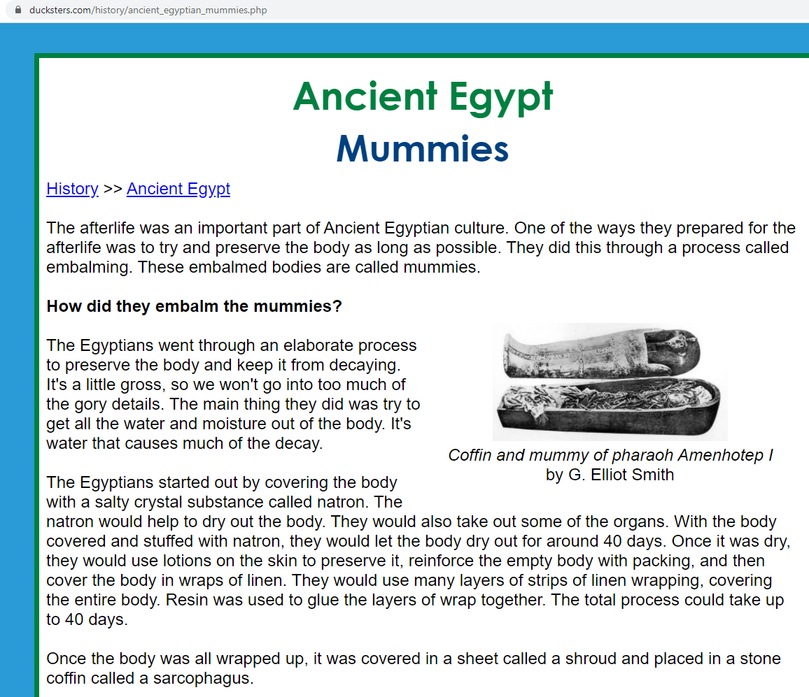**SOURCE THREE** – Webpage Sourced from Ducksters.com (2020)